- ACCESING AND ENTERING DATA

- Open MS Access File by clicking “File” in the Menu Bar. Next, click “Open” to find the Database.
- Just click “File” in the Menu Bar then click Log-In.

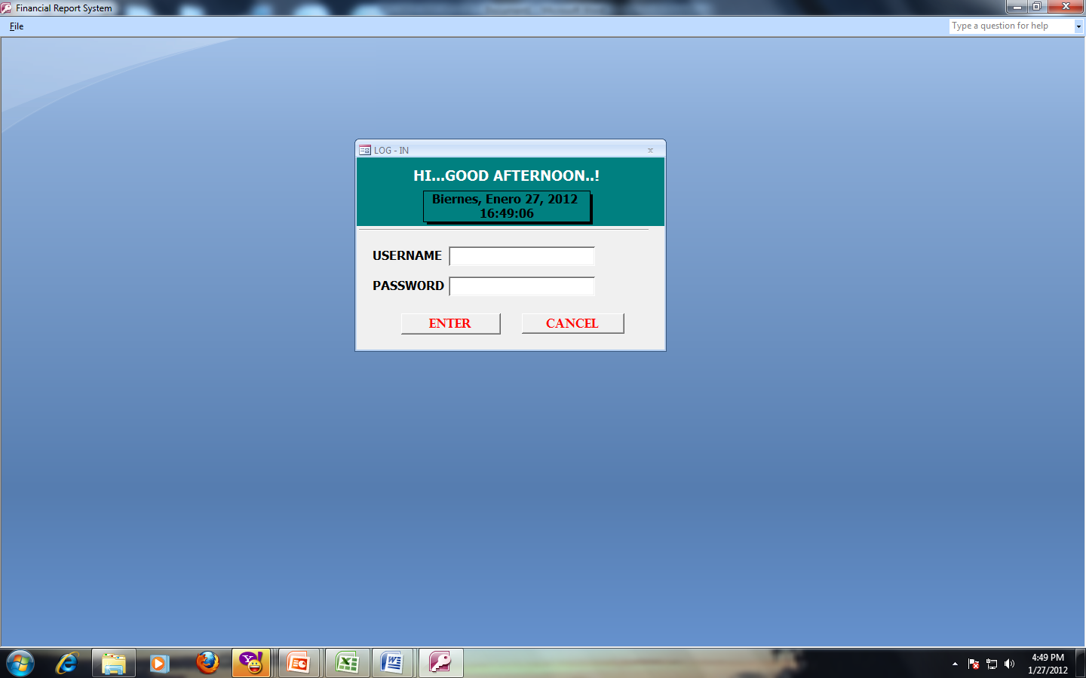

- Type Username and Password to enter the Main Switchboard.
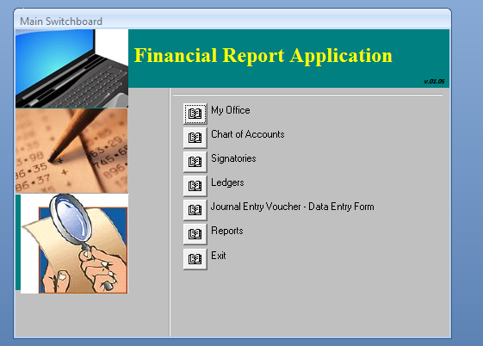

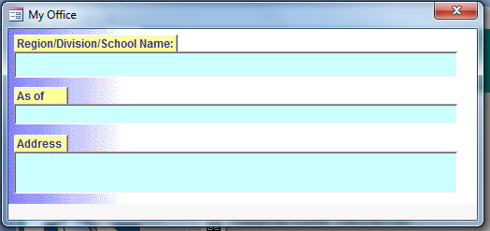
- In “My Office” button, you can write what office are you and address of your office . And also you can write the “As of” of the reports.

- In the Chart of Accounts button, you’ll edit and see all account codes and titles if the account code are not yet include, you can access to add.
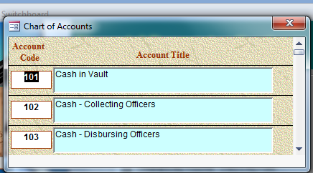

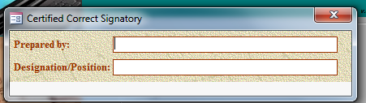
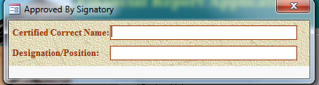
- In the Signatories button, you’ll indicate who prepared and approved the reports.

- In the Ledger button, you’ll put or indicate the Account Name and Creditors Name.
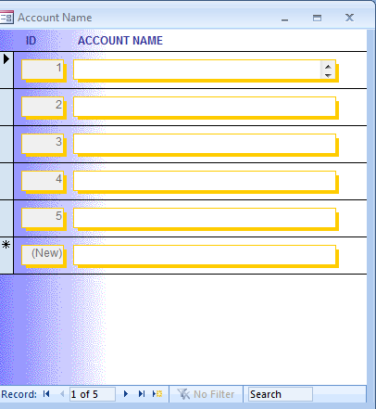
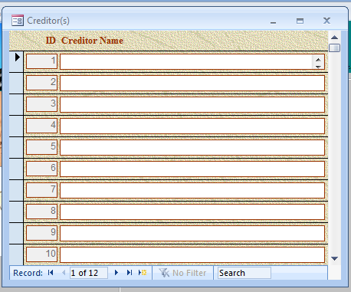

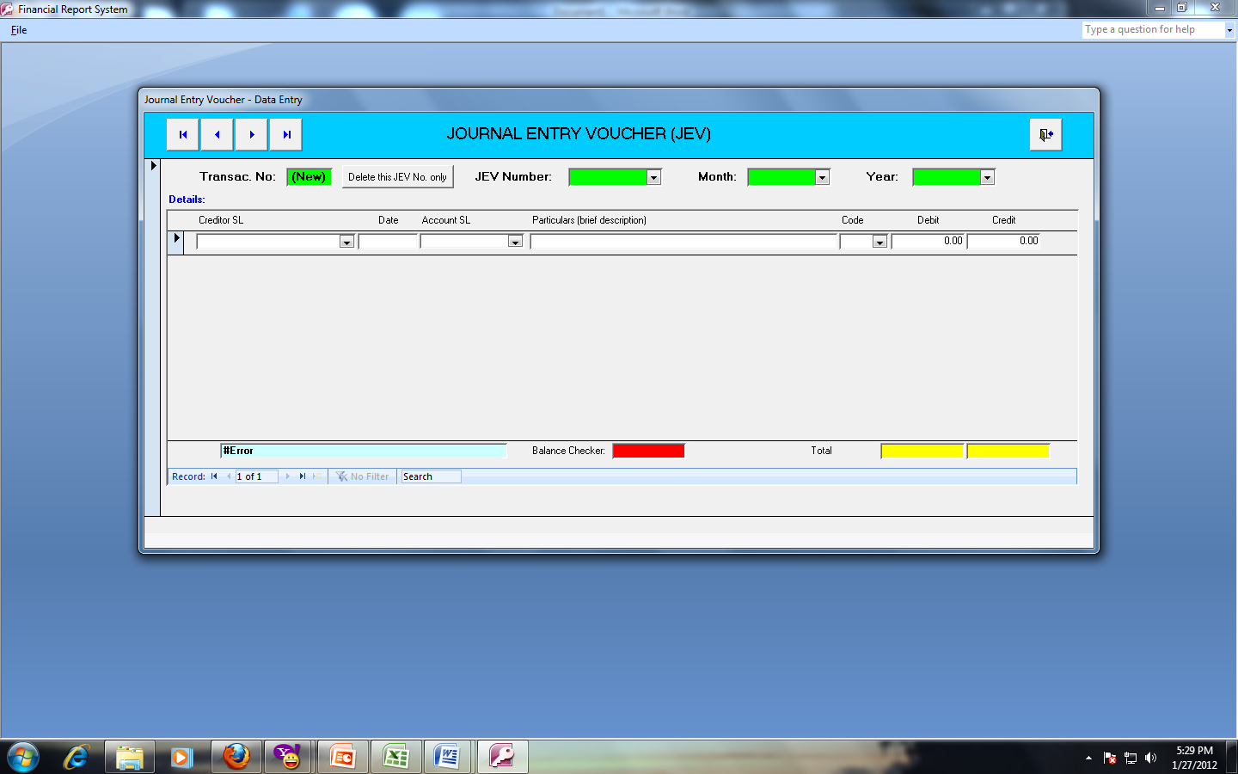
- In JEV Data Entry, you can create a entry per transaction.In this form, you can see the acct name, creditors name, date, particular, acct code and amount (credit & debit). And don’t forget to select the JEV No., month and year for the standard JEV No.

- GENERATING REPORTS

- In the Report button, you will find all reports like JEV, General Ledger, Subsidiary Ledger per Account Name and per Creditors and also monthly Trial Balance.

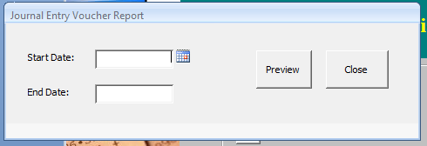
- Simply click the button JEV, to appear the “Filtering Date Form” then type the date of the JEV to see what you want.

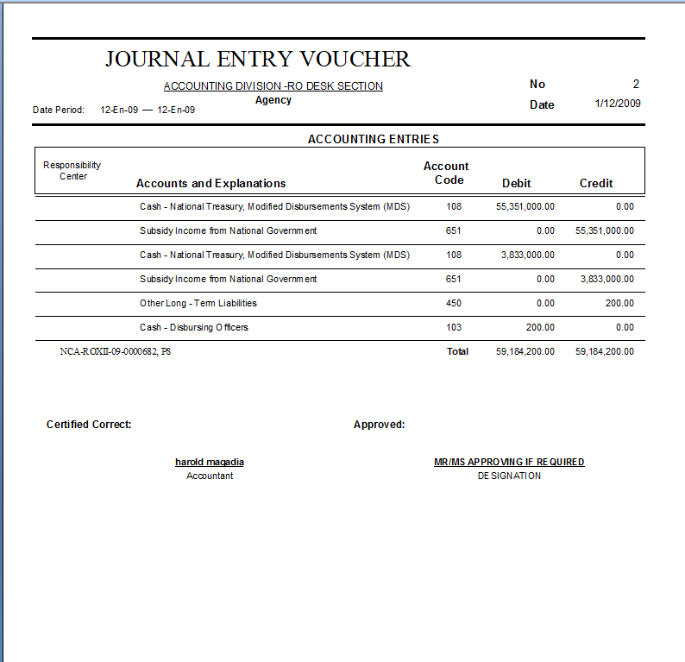

This is sample generated report for JEV.

- In “General Ledger” button also the same step in JEV button because “Filtering Date Form” will appear then type the Start date and End Date. For example in Start Date “1/1/12” and End Date “1/1/12” mean one day report will generate. If you like to generate the report for one month, you will type like this, Start Date “1/1/12” and End Date “1/31/12”.
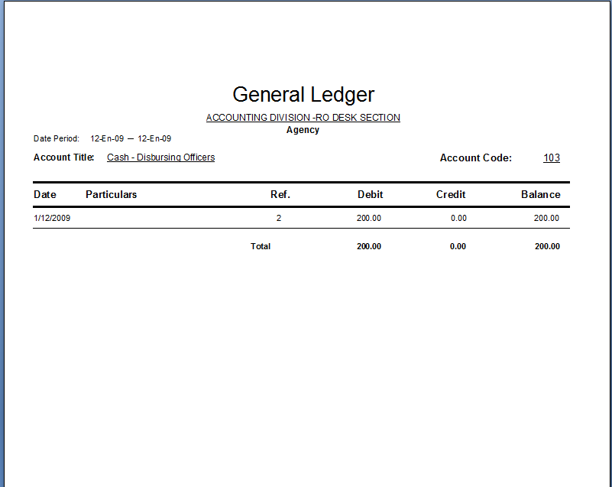

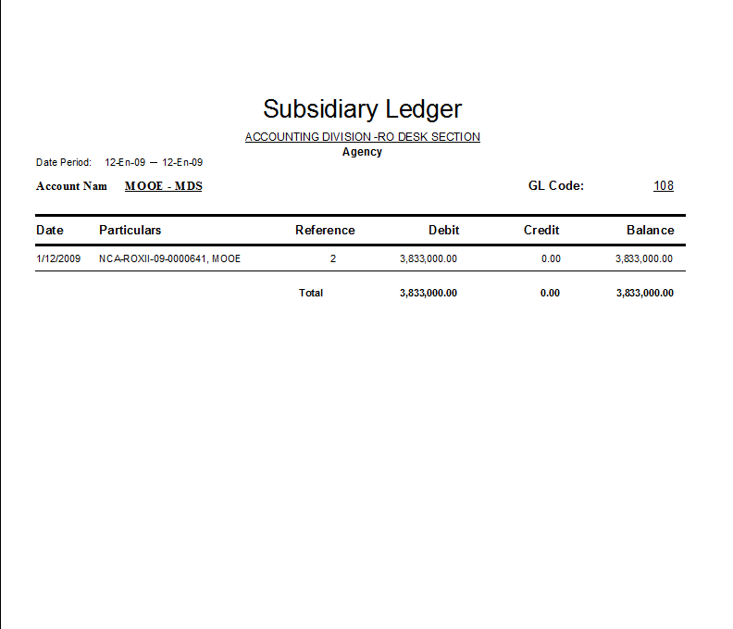
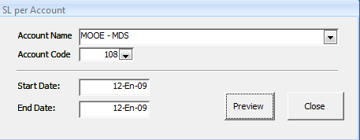
- By clicking the combo list you can select the Account Name then type the Start & End Date of the Subsidiary Ledger to generate this report.

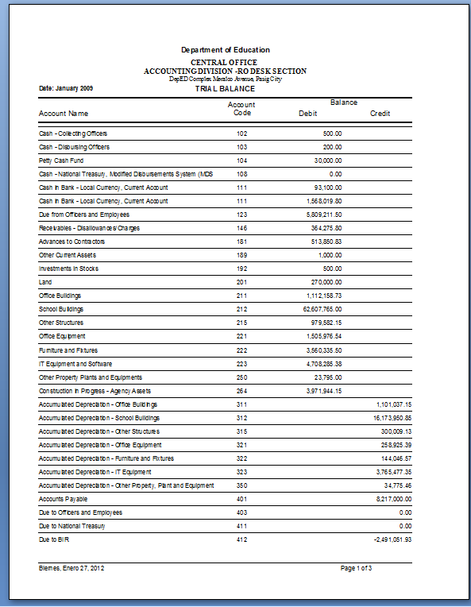
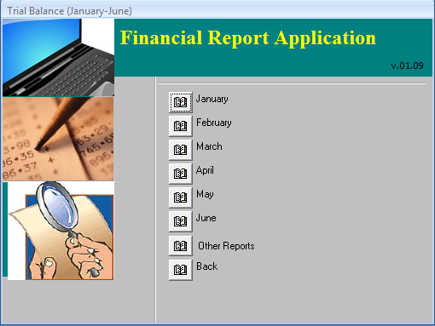
- By clicking the button per month, you will generate the monthly report of trial balance.

User’s Guide

Prepared by:
HAROLD MAGADIA
Accounting Division
Department of Education

