User’s Handbook

Prepared by:
HAROLD MAGADIA
Accounting Division
Department of Education

TABLE OF CONTENTS

- Introduction ..............................................................................................................................
  - The Cash Advance Tracking System- Cash Advance Module ..........................................................................
  - The User’s Handbook .....................................................................................................................................................

- Accessing the Cash Advance Module ..............................................................................
  - Log-In Form ......................................................................................................................................................................
  - Main Page/Data Entry Form .....................................................................................................................................

- Entering/Find Data in the Cash Advance Data Entry Form ..................................
  - Enable/Disable Editing Button .....................................................................................................................................
  - Entering Data ...................................................................................................................................................................
  - Find Data ...........................................................................................................................................................................

- Generating Reports ...............................................................................................................
  - Accessing the Reports ..................................................................................................................................................

- Types of Reports ..................................................................................................................
  - Status of Cash Advance .............................................................................................................................................
  - Summary Overdue Accounts for Liquidations .....................................................................................................
  - Subsidiary Ledger per Employee ..............................................................................................................................
  - Statement of Unliquidated Cash Advance ...........................................................................................................
  - Aging of Cash Advance ...............................................................................................................................................

- INTRODUCTION
  - Cash Advance Tracking System – Cash Adavance Module
    - The Cash Advance Tracking System is used to automate the liquidation of cash advance process.
  - The User’s Handbook
1.1.2 The user’s handbook is meant to serve as a step-by-step on how to operate and access the software application for the Cash Advance Tracking System. It creates any reports like Status of Cash Advance, Aging and etc.,

- ACCESSING THE CASH ADVANCE MODULE
  - Log-In Form
2.2.1 The log-in form appears when the user accesses the Main Switchboard located at the Main Menu. To access the functions of Cash Advance Tracking System, enter the username and password. Username and Password will be give by Mr. Harold Magadia or pls. contact at h_magadia@yahoo.com or (02)633-72-01.
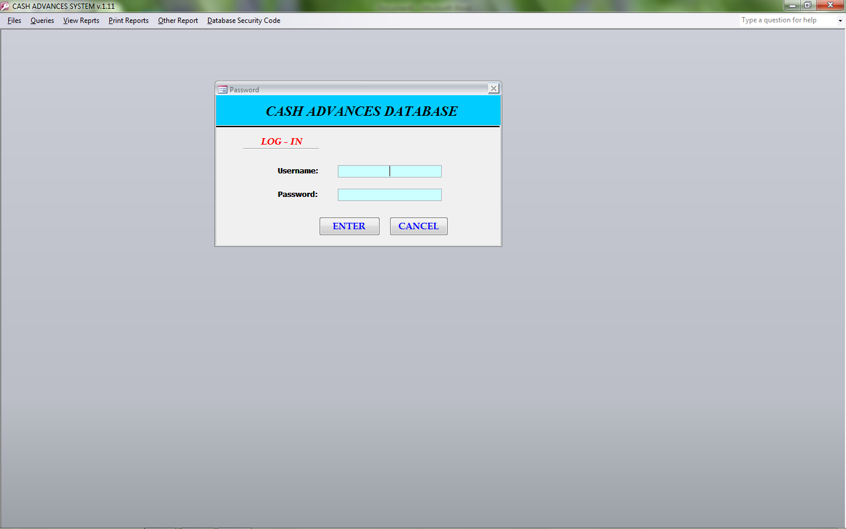

  - Main Page/Data Entry Form
    - Entering the correct username and password will bring the user to the Main Page/Data Entry Form. The features which a user can access through the Data Entry Form will differ depending on the Button assigned.

- Entering/Find Data in the Cash Advance Data Entry Form
  - Locked and Unlocked Editing Button
    - Click the image Key button located in the upper right portion then the Input box will appear then type the Access Code. This is important to the user to modify the data from database. If the access code entered the disable button and field name will appear enable or open.
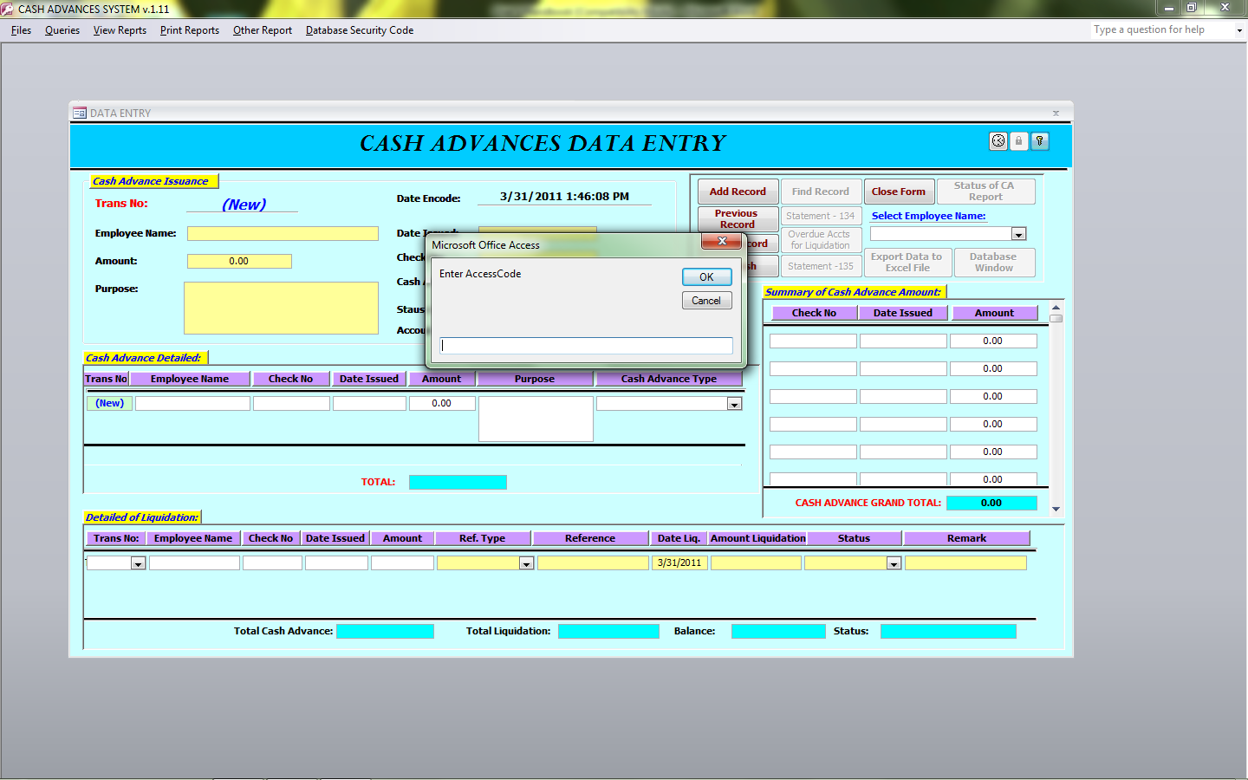

3. 2 Entering Data
3.2.1 Fill in the required data in the yellow box, if you finished to fill up then click Add Record button.
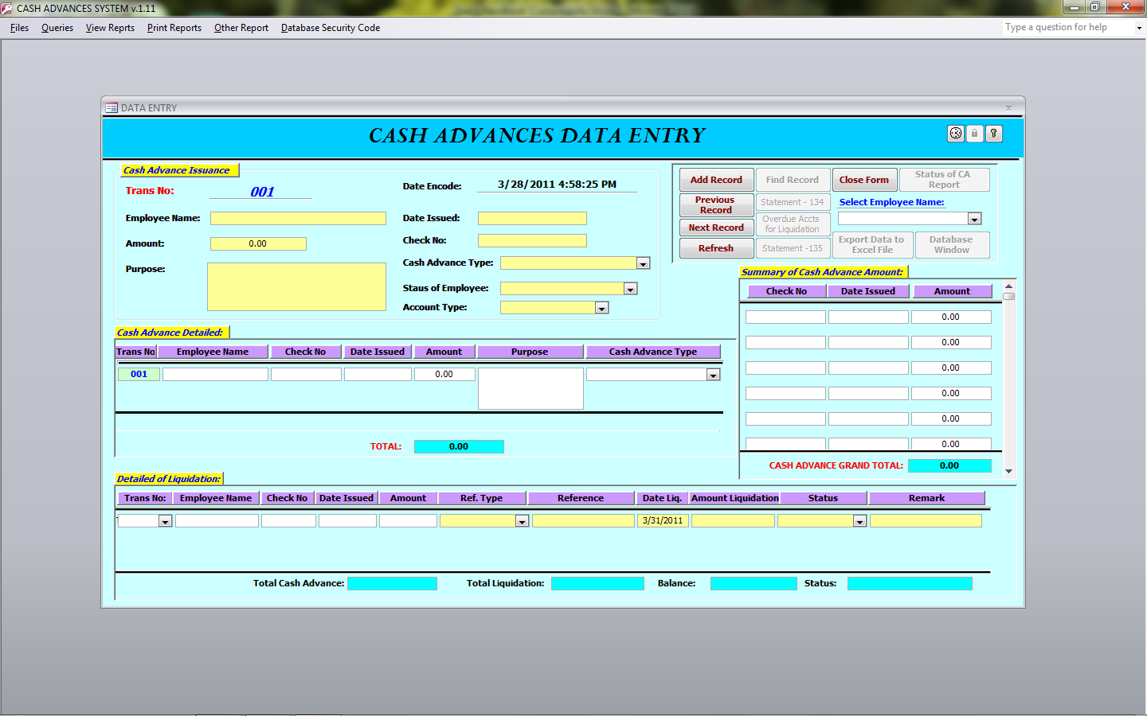

  - Find Record
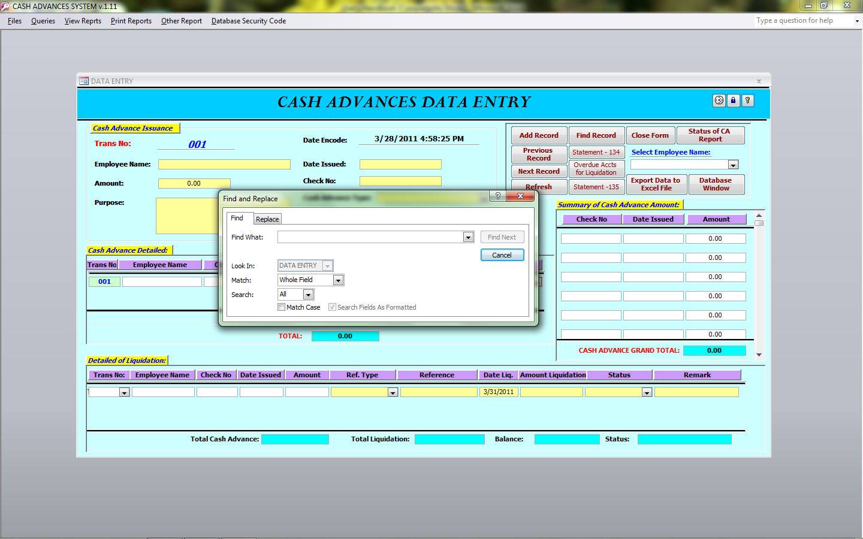
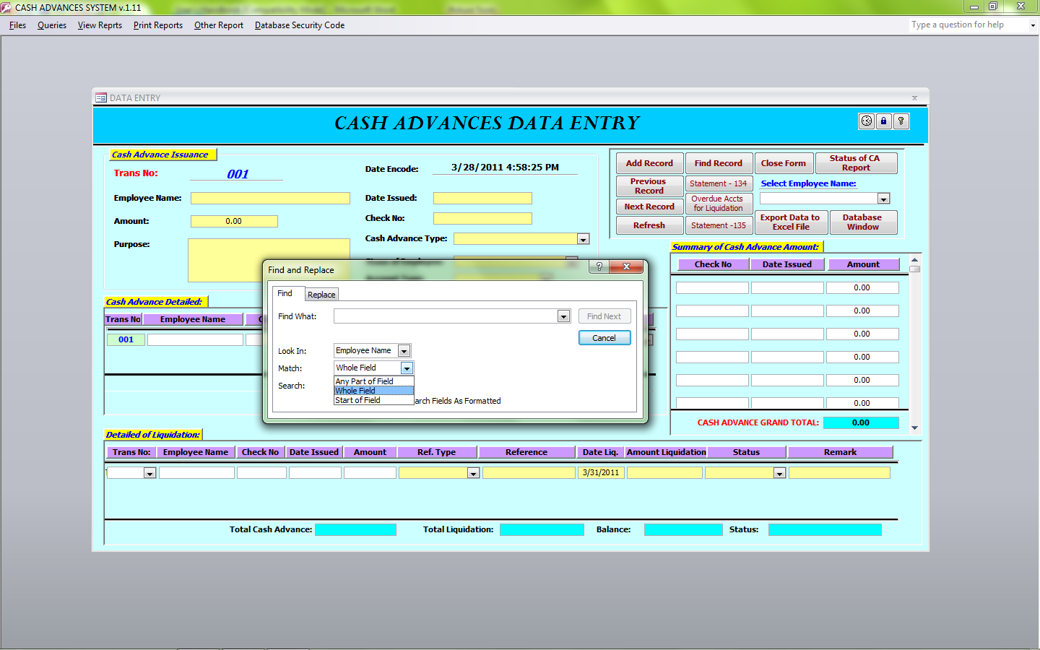
3.3.1 Click the Find Record button then Find and Replace Form will appear. Before you type the Employee Name go to Data Entry first then click the Employee Name. In the Look in the field name will appear then you can type the name of employee then select Any Part of Field and click Find Next button.

- Generating Reports
  - Accessing the Reports Screen
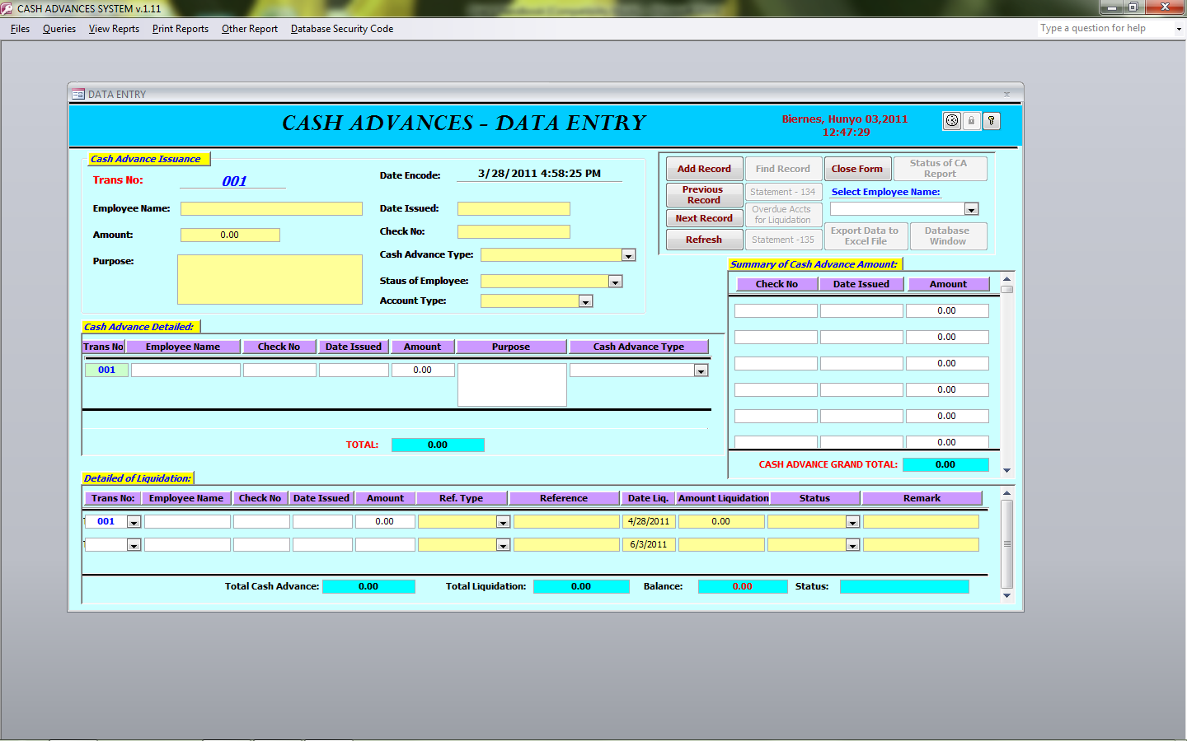
    - The Reports button in the Data Entry Form at the right side of the screen allows you to generate reports available in Cash Advance System. Clicking on the button will bring you to generate reports.
- Type of Reports
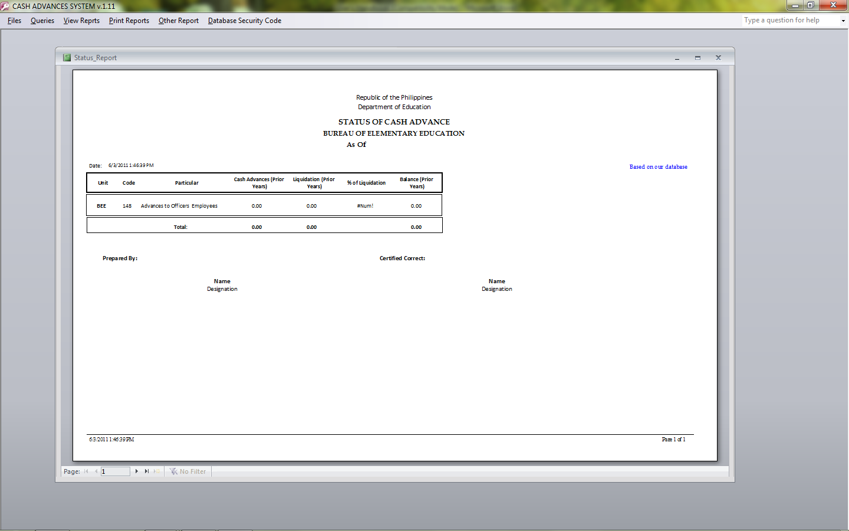
  - Status of Cash Advance

Note: if you click the button of Status CA, the parameter value form will appear pls. type the prior date and current date.
  - Summary of Overdue Accounts for Liquidation

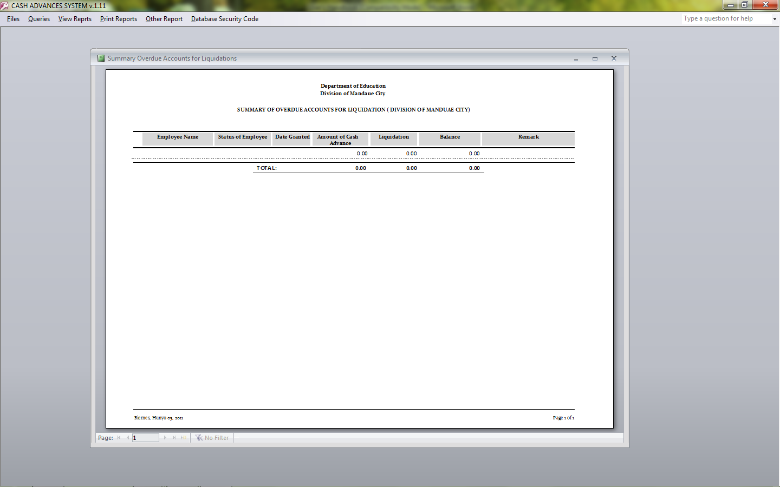

  - Subsidiary Ledger
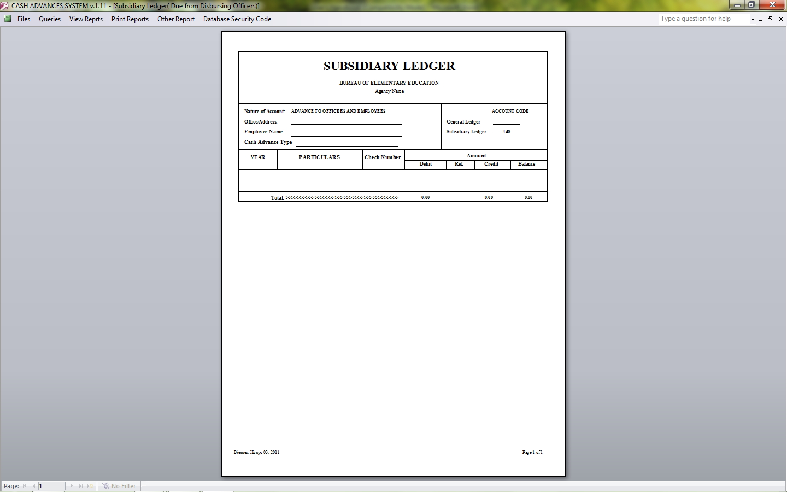

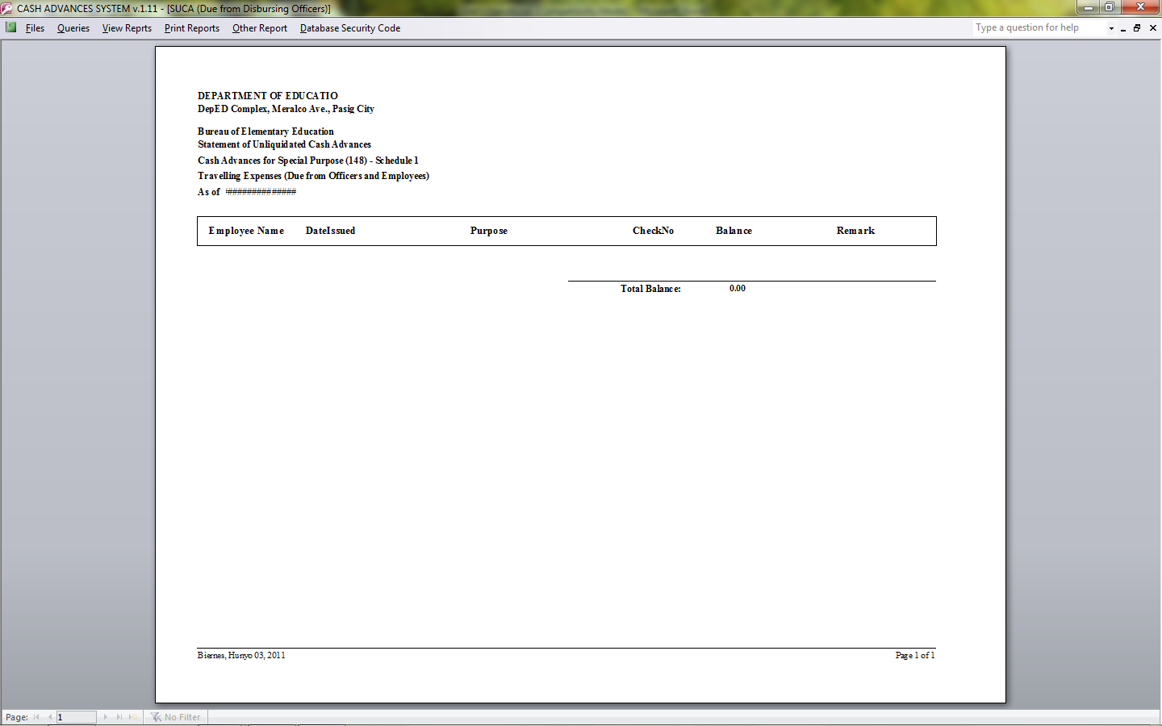
  - Statement of Unliquidated Cash Advance

